LQM-2050: APPENDIX A

WORK INSTRUCTIONS – LOGGING IN

1.0 INITIAL INSPECTION OF SAMPLES
2.0 GIVING EACH SAMPLE A LAB ID
3.0 LOGGING SAMPLES INTO THE MANAGEMENT CONSOLE

1.0 INITIAL INSPECTION OF SAMPLES

1.1 Open package containing samples and locate the F- QAL Submittal Form black & white (hereafter referred to as Submittal Form).

1.2 Separate the samples by matrix. Then organize the samples to follow the order the customer has listed on the Submittal Form sent in the package.

1.3 If there are any inconsistencies between the Submittal Form and the actual samples received, make a notation on the Submittal Form.

2.0 GIVING EACH SAMPLE A LAB ID

2.1 Beginning with the medias, identify the next sequential unused Sample Set number from the Log-In Book. Write this number at the top of the Submittal Form, along with the total number of samples (e.g. “67633-10 medias”).

2.2 Indicate on the Submittal Form, immediately next to the sample description, the numerical sequence of samples (“1(M), 2(M), 3(M)”, etc.).

2.3 Using the Zebra LP2844 Thermal Label Printer and the Lab ID obtained from the Log-In Book, create the bar code labels for the samples (instructions for using the label maker start on page ???).

2.4 Apply the bar code labels to the samples, using the Submittal Form as the guide to what number is applied to what sample.

2.5 Repeat 2.1-2.4 for Soils, Tissue, Waters, and Fertilizers, in that order. A different Sample Set number will be used for each matrix.

2.6 Note: Any tissue sample sent in containers other than paper bags are transferred to a #8 paper bag labeled with the exact same Laboratory Identification Number as originally assigned to the sample.
3.0 LOGGING SAMPLES INTO THE MANAGEMENT CONSOLE

Note: Each matrix has its own Sample Set number, and thus will be entered into the management console separately. Matrices/Sample sets are logged I the same sequence in which they were labeled: Media, Soil, Tissue, Water, Fertilizer.

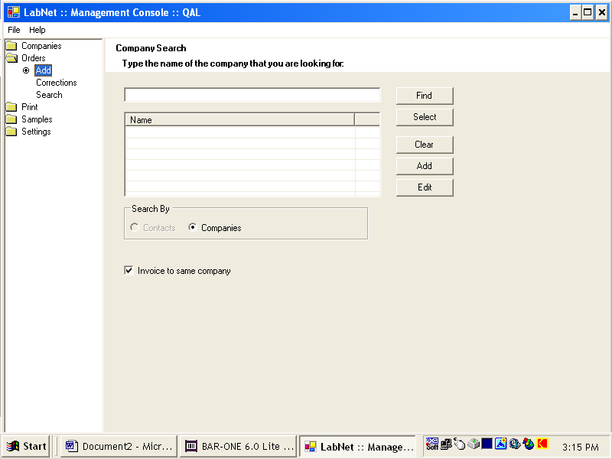

3.1 Finding the customer:
3.1.1 Open up the management Console.
3.1.2 It will automatically open to the correct screen- on the left menu, “”Add” will be highlighted under “Orders”.
3.1.3 Type in the first few letters of the company’s name, and press “Find”.

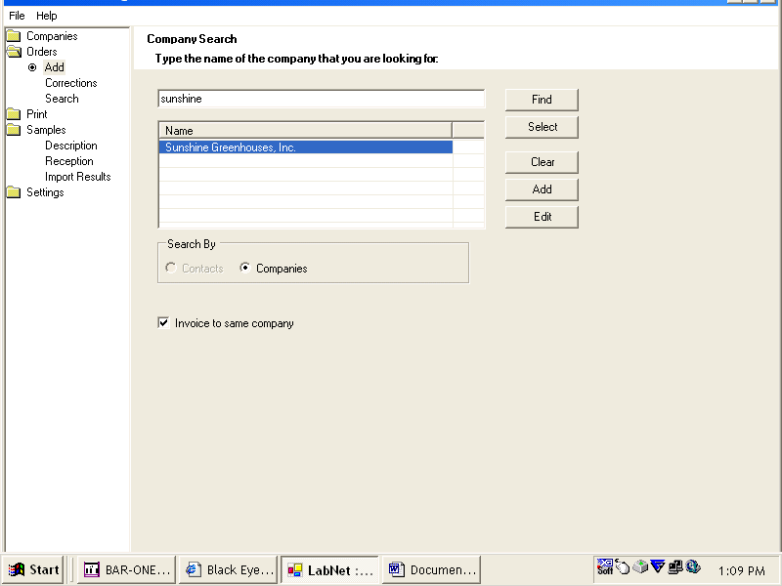

3.2 Selecting the customer:
3.2.1 After you have pressed “Find”, the results of your search will be displayed.
3.2.2 Click on the customer that has sent in the samples.
3.2.3 If the customer is not there, consult the DCS or ADQA. Do not add a customer unless you have prior approval. Instructions for adding a customer begin on page ???.
3.2.4 After the customer you have chosen is highlighted, click “Select”.

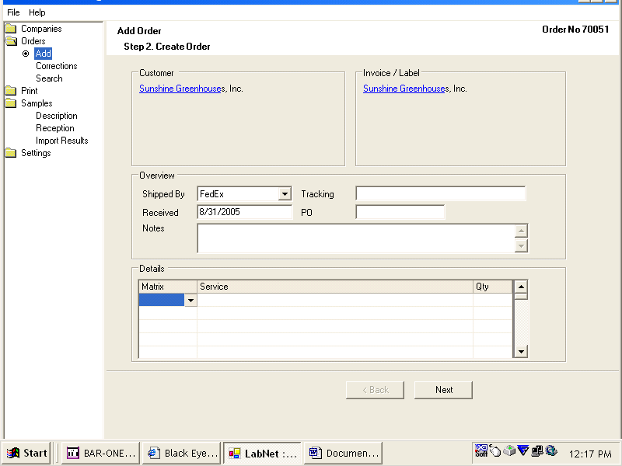

3.3 Inputting batch data:
3.3.1 Open the “Shipped by” drop-down menu and choose the shipper.
3.3.2 Enter the tracking number (or if sent by mail, enter “mailed mm/dd/yy”).
3.3.3 The date “Received” will automatically be filled in with the current date. You do not need to change this.
3.3.4 In the “Notes” box, enter the analysis we will be doing on the samples you are logging in (ex: EMM-100, EMT-300, TM-900.2, etc.).
3.3.5 Open the “Matrix” drop-down menu on the first line of the “Details” box. Choose the matrix you are logging in.
3.3.6 Open the “Service” drop-down menu on the same line. Choose the service.
3.3.7 Enter the quantity of samples on the same line, under “Qty”.
3.3.8 DO NOT hit the “Next’ button yet.

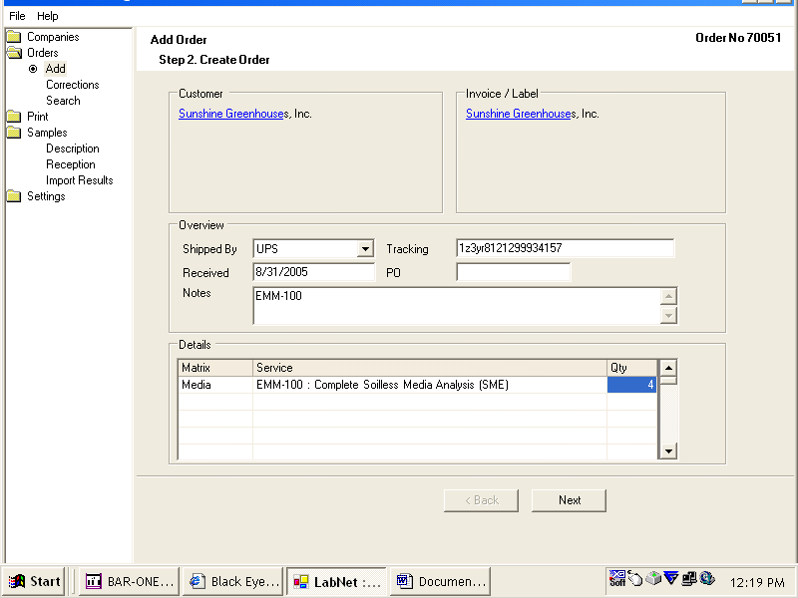

3.4 Double-checking the information:
3.4.1 After all the information is entered, your screen should appear similar to the picture above.
3.4.2 Double-check all information is entered and is correct.
3.4.3 Click the “Next’ button.

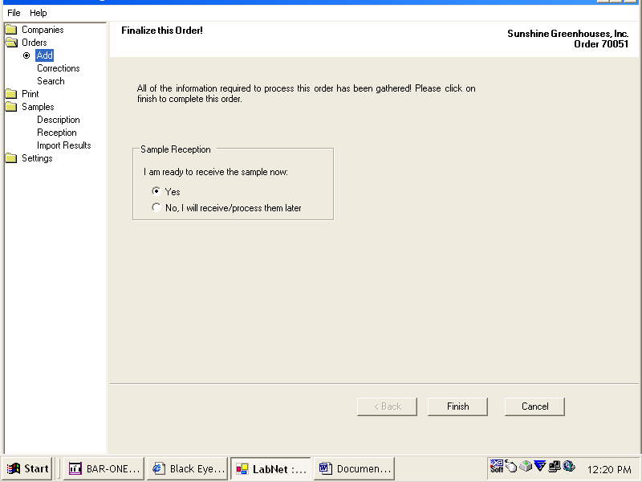

3.5 “Finalize this Order” Screen:
3.5.1 Nothing is required to be entered in this screen. Click “Finish”.

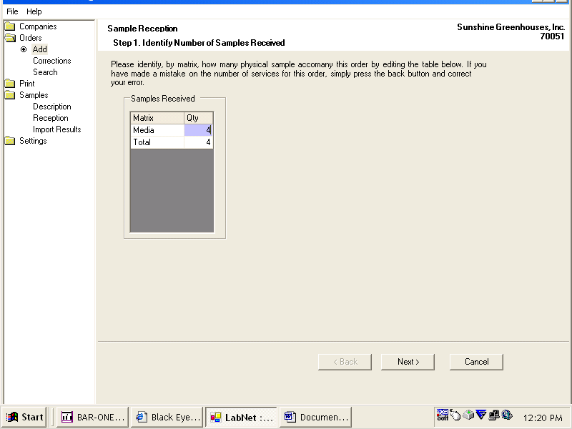

3.6 “Sample Reception, Step 1” Screen:
3.6.1 Click in the purple-highlighted box, and enter the number of samples you have (for this matrix only.
3.6.2 Click “Next”.

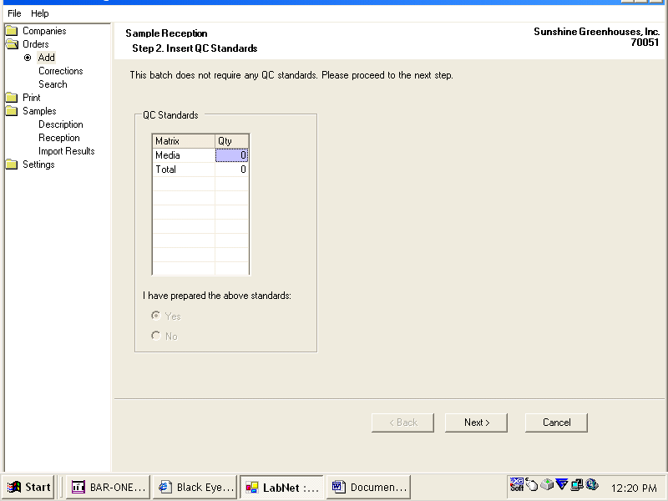

3.7 “Sample Reception, Step 2” Screen:
3.7.1 Nothing is required to be entered in this screen. Click “Next”.

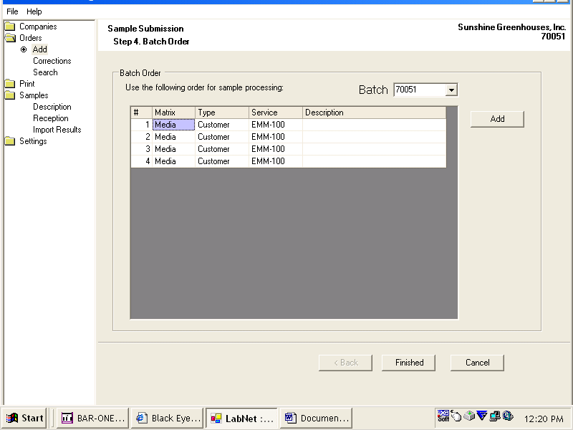

3.8 “Sample Reception, Step 4” Screen:
3.8.1 Nothing is required to be entered in this screen. Click “Finished”.

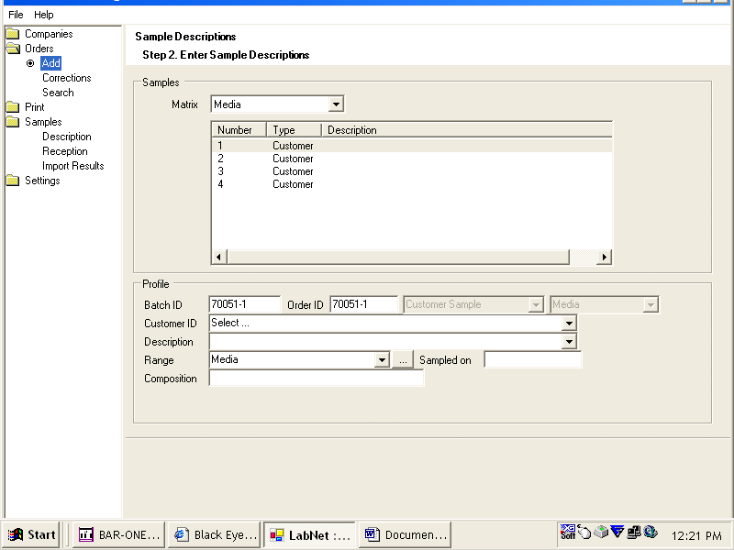

3.9 “Sample Descriptions, Step 2” Screen:
3.9.1 The first sample automatically is selected.
3.9.2 In the “Description” box, enter the sample description for the first sample of the batch.
3.9.3 Open the menu to choose the “Range” (Note- do not use the drop-down arrow- use the bottom to the right of the arrow to open the menu).
3.9.4 Click on the appropriate range for the sample. The menu will automatically close.
3.9.5 Enter the date the sample was take in the “Sampled on” box.
3.9.6 Click on number “2” to proceed to the second sample. Repeat 3.9.2-3.9.5 for the remaining samples.

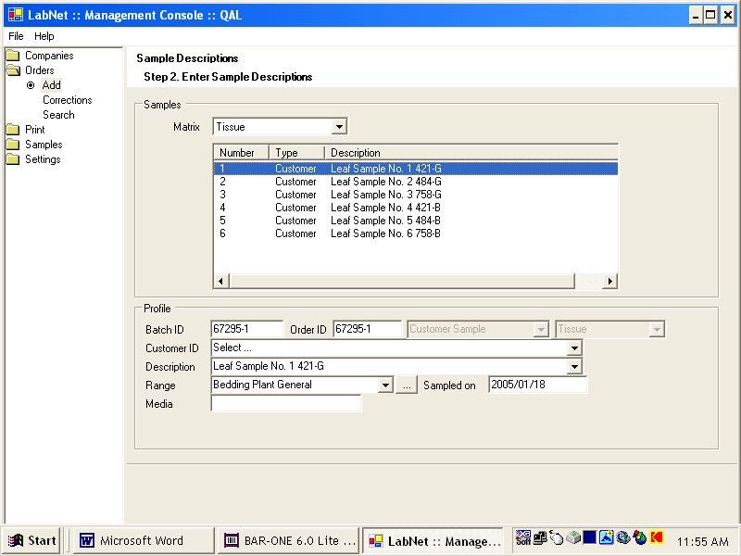

3.10 Passing the samples over for extraction/analysis:
3.10.1 When the information has been entered for all of the samples, click back on number “1” and wait for the information for the first sample to reappear.


3.10.2 Move the samples over to the cart. As you place the samples on the cart, YOU MUST DOUBLE-CHECK THE LAB ID OF EVERY SAMPLE ON THE BAG AGAINST THE INFORMATION IN THE MANAGEMENT CONSOLE.
3.10.3 Repeat 3.1-3.10 for the next matrix, until all matrices have been logged in.

3.11 Blanks:
3.11.1 After all customer samples have been logged in, log in an additional QC sample for each matrix (media blank, tissue blank and QC, water/fertilizer blank).
4.0 Creating Batch Logs

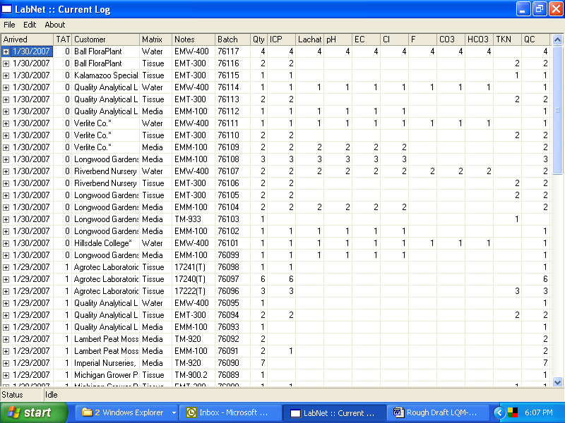

4.1 Opening and organizing the log:
4.1.1 Open the log by clicking on the “log” shortcut on the desktop.
4.1.2 Re-arrange the first 17 columns of the log to match the picture above.
4.1.3 All extra columns (such as Pathology”, “Physical”, etc.) should be placed to the right of the “QC” column, in any order.

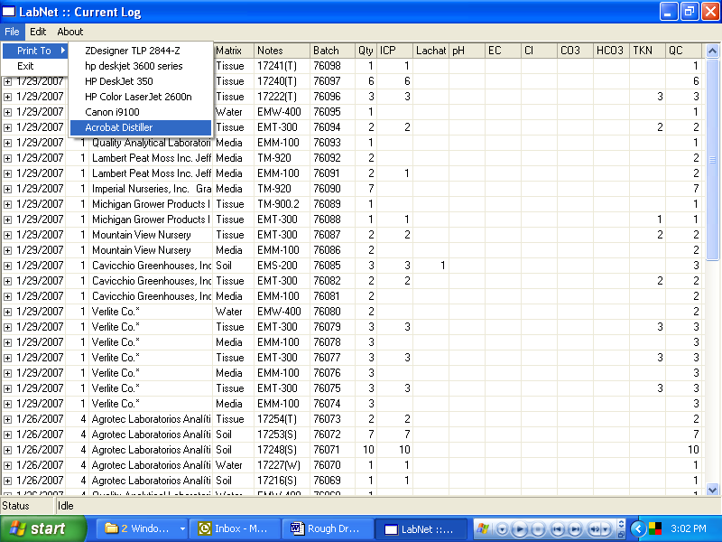

4.2 Printing the log, Step 1:
4.2.1 Choose “File”, then “Print to”, then “Acrobat Distiller”.
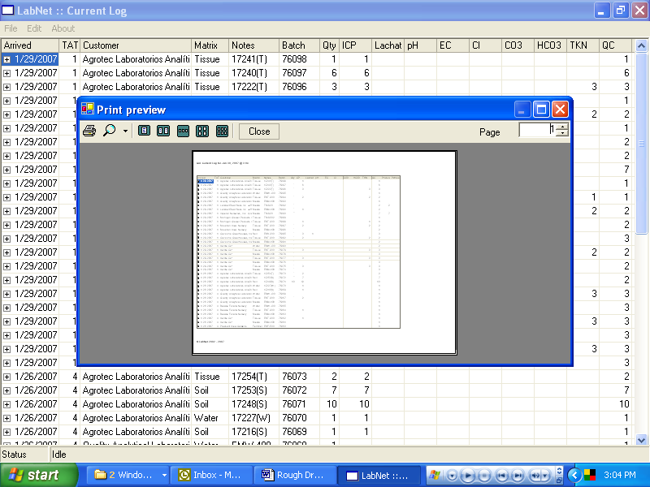

4.3 Printing the log, Step 2:
4.3.1 The picture above will be on the screen.
4.3.2 Within the “Print Preview” box, click on the printer icon.

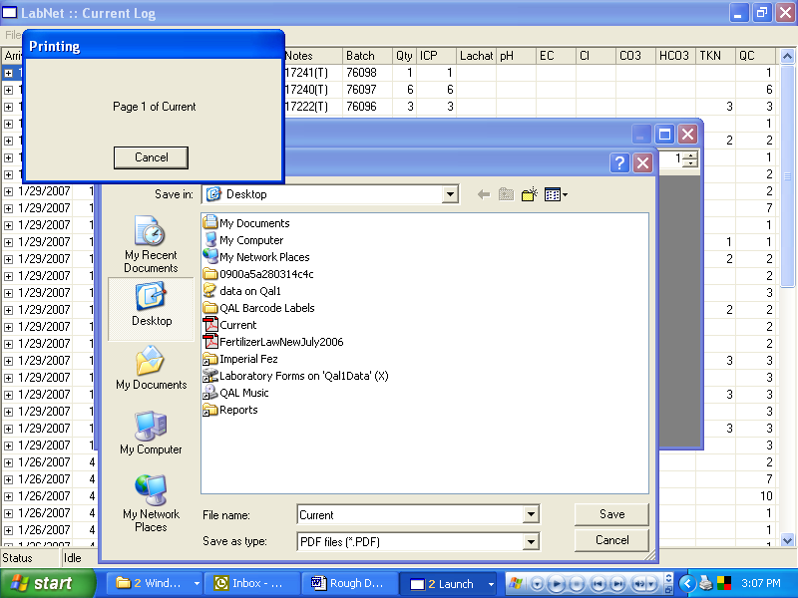

4.4 Printing the log, Step 3:
4.4.1 The picture above will be on the screen.
4.4.2 The file name “Current” will appear by default. This is the correct name, and does not need to be changed.
4.4.3 Click “Save”.
4.4.4 It will ask you if you wish to overwrite the file that already exists with the same name. Click “Yes”.

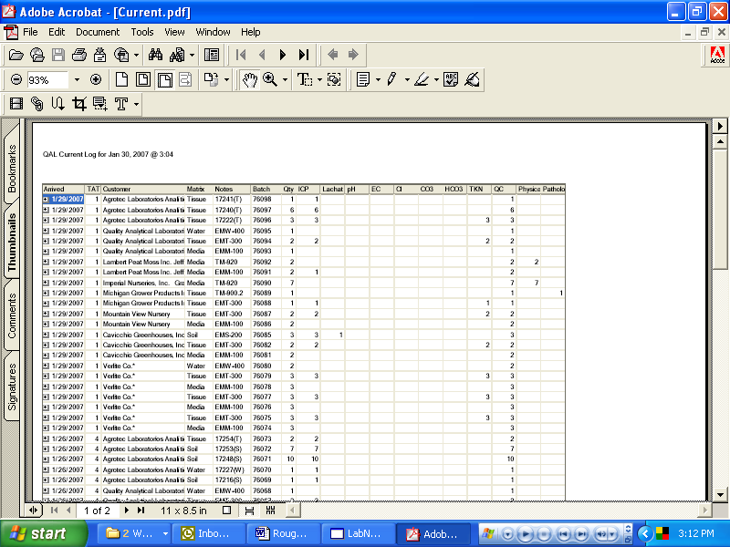

4.5 Printing the log, Step 4:
4.5.1 After you click “Yes” to overwrite the file, the Adobe Acrobat program (and file “Current.pdf”) will automatically open up. This may take a few moments.
4.5.2 Use the Adobe print icon to print out a copy of the current log for each batch (matrix) of samples logged in today. Normally you will only need to print the first page of the log.

5.0 Making Bar-Code labels

